Project Planning Phase
Project Planning Template (Product Backlog, Sprint Planning, Stories, Story points)

Date | 30 September 2026
Team ID | SWTID-2026-1259
Project Name | Streamlining IT Procurement: Automating Standard Laptop Orders with Flow Designer
Maximum Marks | 5 Marks

Product Backlog, Sprint Schedule, and Estimation (4 Marks)
Use the below template to create product backlog and sprint schedule
Sprint | Functional Requirement (Epic) | User Story Number | User Story / Task | Story Points | Priority | Team Members
Sprint-1 | Order Standard Laptop | USN-1 | As a requester, I can open the Service Catalog, go to Hardware and select the Standard Laptop item so that I can raise a laptop request. | 1 | High
Sprint-1 |  | USN-2 | As a requester, I can choose optional software (Adobe Acrobat / Photoshop), add additional software requirements and click Order Now to place the request. | 2 | High
Sprint-2 | Track Request | USN-3 | As a requester, I can open my Request Number and view the Requested Item and its catalog tasks so that I can track the progress of my laptop. | 2 | Medium
Sprint-1 | Approval | USN-4 | As an approver, I can view the pending approval under the Approvers section of the request. | 1 | High
Sprint-1 |  | USN-5 | As an approver, I can approve or reject the laptop request so that procurement can proceed. | 2 | High
Sprint-1 | Create Flow | USN-6 | As an administrator, I can create a flow named 'Standard Laptop task' in Flow Designer (Application: Global, Run As: System User) so that laptop tasks can be automated. | 2 | High
Sprint-1 |  | USN-7 | As an administrator, I can add the Service Catalog trigger and the 'Create Catalog Task' action (short description 'Laptop needs to Configured', Assignment group 'Hardware', Approval 'Approved') so that a task is generated automatically. | 5 | High
Sprint-2 | Flow Assignment | USN-8 | As an administrator, I can attach the 'Standard Laptop task' flow to the Standard Laptop catalog item under Maintain Items > Process Engine so that it runs for every order. | 3 | High
Sprint-2 | Task Assignment | USN-9 | As a hardware team member, I receive a catalog task (SCTASK) automatically assigned to the Hardware group when a standard laptop is ordered. | 3 | High
Sprint-3 | Laptop Configuration | USN-10 | As a hardware team member, I can open the catalog task, work on it and close it after configuring the laptop so that it is ready on arrival. | 3 | Medium
Sprint-2 | Process Automation | USN-11 | As an IT procurement team member, I want tasks to be generated and assigned to the hardware team automatically so that manual intervention and errors are reduced. | 3 | High

Project Tracker, Velocity & Burndown Chart: (4 Marks)
Sprint | Total Story Points | Duration | Sprint Start Date | Sprint End Date (Planned) | Story Points Completed (as on Planned End Date) | Sprint Release Date (Actual)
Sprint-1 | 13 | 6 Days | 05 Oct 2026 | 10 Oct 2026
Sprint-2 | 11 | 6 Days | 12 Oct 2026 | 17 Oct 2026
Sprint-3 | 3 | 6 Days | 19 Oct 2026 | 24 Oct 2026
Total | 27 | 18 Days

Velocity:
Our project has 3 sprints of 6 days each and 27 story points in total (13 + 11 + 3). Team velocity = total story points / number of sprints = 27 / 3 = 9 story points per sprint. Average velocity (AV) per iteration unit (story points per day) = velocity / sprint duration = 9 / 6 = 1.5 story points per day.
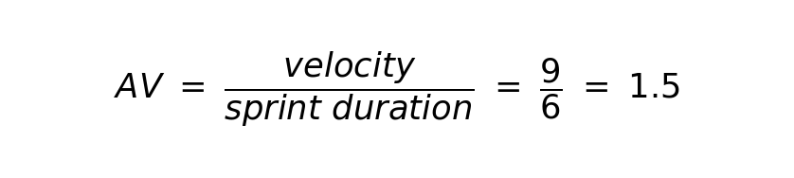

Burndown Chart:
A burn down chart is a graphical representation of work left to do versus time. It is often used in agile software development methodologies such as Scrum. However, burn down charts can be applied to any project containing measurable progress over time.
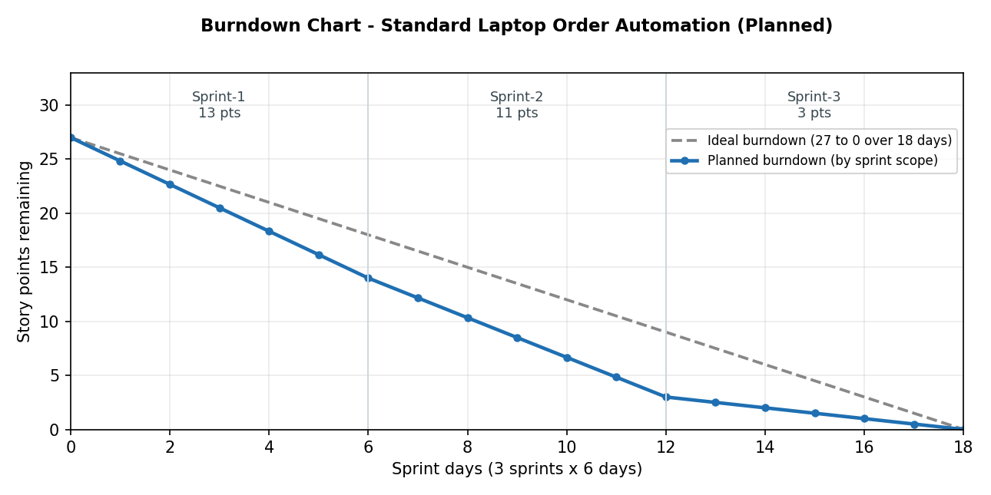

https://www.visual-paradigm.com/scrum/scrum-burndown-chart/
https://www.atlassian.com/agile/tutorials/burndown-charts

Reference:
https://www.atlassian.com/agile/project-management
https://www.atlassian.com/agile/tutorials/how-to-do-scrum-with-jira-software
https://www.atlassian.com/agile/tutorials/epics
https://www.atlassian.com/agile/tutorials/sprints
https://www.atlassian.com/agile/project-management/estimation
https://www.atlassian.com/agile/tutorials/burndown-charts

